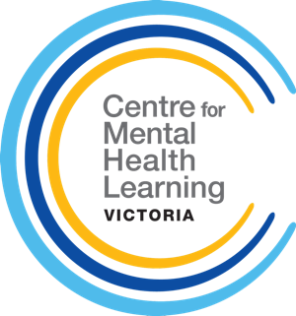
REQUEST FOR CMHL TRAINING

Full Name _____________________________________________________________
Position at Service _______________________________________________________
Email Address _______________________________________________________
Phone Number _______________________________________________________
Area Mental Health & Wellbeing Service _____________________________________
Address of Service _______________________________________________________

We are interested in having CMHL visit our service to deliver the following training (select multiple if applicable, and number in order of priority):

Facilitating Groups (All disciplines. Max 25 participants)

Finding Your Voice (Enrolled Nurses Only)

2-Day Beginner Clinical Supervision
(Nursing and allied health disciplines only. Maximum 25 participants)
Suicide Risk: Understanding, Responding and Engaging
(AMHS staff only. Maximum 25 participants)
Other (please provide detail):

Expected number of participants (if you have selected multiple training sessions above, please advise the expected number for each session): ￼__________________________

INFORMATION TO NOTE:
- It is the responsibility of the AMHS to provide a training space with IT, tables and chairs, and a whiteboard (if possible).
- CMHL are not able to provide catering. The service may provide their own catering or provide a venue that is close to food options.
- CMHL will manage registration and event communication with participants.

Please email this completed form to cmhl.events@cmhl.org.au and the CMHL Learning & Practice Development team will be in contact.

