Introduction to
Lived Experience Roles

In History of the Lived Experience Workforce in Victoria, we explained how lived experience positions grew organically in services. This has resulted in confusion because of the inconsistent use and understanding of the terms ‘peer support’, ‘peer work’, ‘peer support work’ and ‘lived experience work’. With recent, rapid expansion of the lived experience workforces, role confusion has increased and this emphasises the need to differentiate the work undertaken by lived experience workers. We hope this resource makes the meaning of all these terms clearer.

Peer Support
Informal peer support, has origins as far back as the 1900’s in France, although grass roots mutual self-help organisations such as Alcoholics Anonymous and Grow grew in popularity from the 1950s onwards.
The Mental Health Foundation (UK) define peer support as follows:
Peer Support may be defined as the help and support that people with lived experience of a mental illness or a learning disability are able to give to one another. It may be social, emotional or practical support but importantly this support is mutually offered and reciprocal, allowing peers to benefit from the support whether they are giving or receiving it. (2018)
Peer support occurs when two or more people with similar experiences share those experiences and gain benefit from each other.

Peer Work
Figure 1 - Lived experience work (Downes & Edan, 2017)
The term peer work, is a collective term for a broad range of roles, where lived experience is an essential requirement. The term is often confused with or used to describe peer support work, therefore we have chosen to use the terms ‘lived experience work’ and ‘lived experience workforce’ to clearly express where we are referring to the broad range of lived experience (or peer) roles, not only peer support work.
Figure 1 shows that lived experience work is grounded in and draws on informal peer support. The diagram also shows the relationship between various roles lived experience workers perform. While there is some overlap between different lived experience roles, there are skills that are specific to the identified role.

Consumer and family carer work.
Another area of confusion has been that of differentiating the work of consumer perspective workers and family carer perspective workers with some services employing the one person to utilise both perspectives in their work.
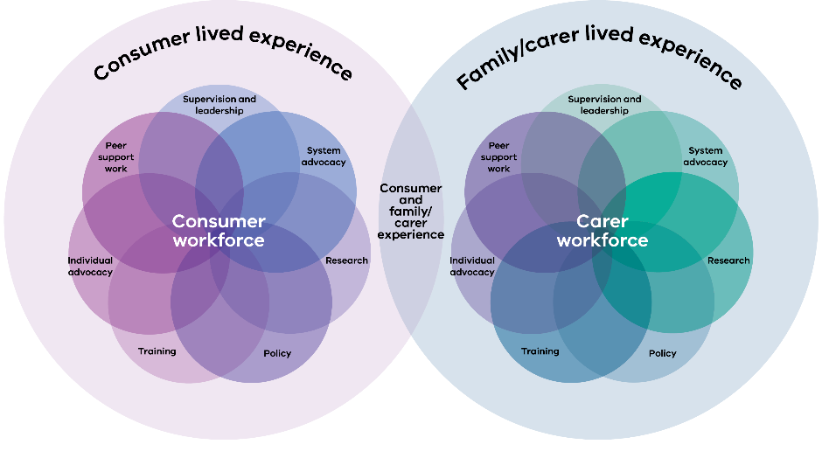
While acknowledging that there is group of people that have both consumer and family carer experiences, there are times when there are differences or tensions between consumer and family carer experiences, needs and expectations. It is import therefore to separate the roles to ensure that the focus of consumer workers is on consumer experiences and the focus of family carer workers is on family carer experiences. This is true whether the role is focussed on the individual (such as individual advocacy, or peer support work), or focussed on broader systems (such as education and training roles, or policy advisor roles). Figure 2 illustrates where there is interconnectedness of lived experience there is still separation of the roles.
Figure 2 - Consumer and family/carer lived experience work (Downes & Edan, 2017)

Brief description of roles and functions
Peer Support Work
Peer support work focusses on building mutual and reciprocal relationships where understanding and emotional, social, spiritual and physical wellbeing and recovery are possible. This is highly skilled and specialised work which requires training and ongoing supervision from experienced peer support workers.
Consumer Peer Support Workers use their personal lived experience of ‘mental illness’ and recovery to support other consumers.
Family Carer Peer Support Workers use their experience of supporting a family member or friend who has experienced ‘mental illness’ to support family members and friends of consumers.

Consultants
The focus of consultant work is service improvement, with particular attention to practices, policies and procedures that effect access and equity. This work is sometimes referred to as service advocacy and involves leadership, co-design, community engagement, networking, planning, evaluation, facilitation and communication skills.
Consumer Consultants collate information and feedback from consumers about their views and experiences of the service and use this information to make recommendations for service improvement.
Family Carer Consultants collate information and feedback from families and carers about their views and experiences of the service.
Managers, coordinators, team leaders
There are some unique challenges for workers who choose to work from a lived experience perspective. It is important that management recognise this, and provide appropriate management structures. Lived experience managers (coordinators, team leaders) are experienced consumer or family carer workers who have responsibility for the support and development of other lived experience workers. Depending on the orgnisational needs, structures and the number of workers from each perspective employed, these leadership roles would ideally support workers from within their discipline, i.e. a consumer team leader for consumer workers and a family carer team leader for family carer workers.
Consumer and Family Carer Educators
Lived experience educators make a significant difference to education and training outcomes for mental health professionals. Consumer and Family Carer Educators ensure consumer and family carer perspectives, participation and involvement are included in all aspects of education and training provided in services. Consumer and Family Carer Educators also develop and facilitate or co-facilitate education and training for staff, consumers, families and other carers, as well as the general community.
Advocates
Advocates support an individual or group to speak on their own behalf and in their own interests, or they may speak for and/or on behalf of an individual or group under instruction. In disability work the first approach should always be one of self-advocacy with paid advocates supporting individuals to advocate for themselves. Advocates often assist with resolving issues at an individual level, for example: assisting someone to ask about medication issues, or to access social housing; or assisting a family member to obtain the Carer Payment.
Consumer Advocates support consumers to have a voice and participate in decisions which affect them.
Family and Carer Advocates support family and carers to be heard about issues that affect them.
“Advocacy usually occurs under potentially difficult conditions when the individual is trying to achieve an outcome which may be at odds with the stated and unstated outcomes desired by the organisation and or its staff.” (Southern Health , 2010) For this reason, advocates are usually employed by Consumer or Carer Peaks or by advocacy organisations.

Policy Advisors
Systemic advocacy is used to describe work that attempts to resolve collective issues at a systemic and/or community level. Peak organisations have a prominent role in this work, and individuals employed in organisations and services can also undertake this work. The report Real Lives, Real Jobs describes the consumer body of knowledge as being “wider knowledge of the kinds of experiences and everyday life issues that consumers face, their current and historical situation collectively, as well as the nature of the service systems and discourses that affect consumers” (Bennetts, 2009, p. 7).
Consumer Policy Advisors draw on the considerable body of collective consumer knowledge and research (both published and in the grey literature) to inform systemic change and bring about change to laws, policy, procedures and bureaucracy which cause or perpetuate injustice or inequity.
Family Carer Policy Advisors, similarly draw on the body of collective carer knowledge and research to inform changes to those aspects of the mental health system that impact on families and carers and to promote family carer sensitive practice.
Research
There is a growing understanding of the importance of utlising lived experience expertise in research. The National Health and Medical Research Council (NHMRC) guidelines include criteria regarding the involvement and participation of consumers in health research.
Consumer and Family Carer Researchers draw on their lived experience to promote and enable the engagement of consumers and carers at all stages of research. Consumer and Carer Researchers may be involved as advisors in others’ research, as partners in collaborative research, or as leaders - initiating, directing and driving research.
Practice supervision
A growing need in lived experience work is for practice supervision from those with experience working in a designated lived experience role. Given the challenges often encountered by lived experience workers it is important that provision of discipline specific, supervision from experienced workers is available. Practice supervisors with experience in consumer or family carer work can provide coaching, mentoring or supervision to other consumer or family carer workers respectively as well as to others working in mental health services. This might be provided internally or sourced from external agencies or private providers.

References
Bennetts, W. (2009). Real Lives, Real Jobs. Melbourne: Psychosocial Research Centre.
Foundation, M. H. (2018). Peer Support. Retrieved January 4, 2018, from Mental Health Foundation: https://www.mentalhealth.org.uk/a-to-z/p/peer-support
NSW Mental Health Commission. (2019). The case for peer work. Retrieved from Peer Work Hub: http://peerworkhub.com.au/the-case-for-peer-work/peer-work-unpacked-roles-and-functions/
Southern Health . (2010). Instilling Hope: a five year plan for the Consumer and Carer Relations Directorate. Southern Health Consumer & Family / Carer Relations Directorate.

Feedback, comments and suggestions
We welcome your ideas about what’s helpful and how we can improve this resource. Please contact us:
@CMHLvic
peerinside@cmhl.org.au
cmhl.org.au

We acknowledge Vrinda Edan’s considerable input into this tipsheet.

